C:\Users\John\AppData\Roaming\Microsoft\Windows\Start Menu\Programs\accounting.jrfcorp.net (RADC)

HKEY_CURRENT_USER\SOFTWARE\Microsoft\Workspaces\Feeds\{02A14074-52A0-4BF1-9F77-2A0707ECDFF7}\ResourceMap\AlternativeSoft (saunders.jrfcorp.net)

HKEY_LOCAL_MACHINE\SYSTEM\CurrentControlSet\Services\Eventlog\Application

HKEY_CURRENT_USER\SOFTWARE\Microsoft\Workspaces\Feeds

<https://msdn.microsoft.com/en-us/library/windows/desktop/cc144191(v=vs.85).aspx>

**xwizard.exe RunWizard {7940ACF8-60BA-4213-A7C3-F3B400EE266D}**

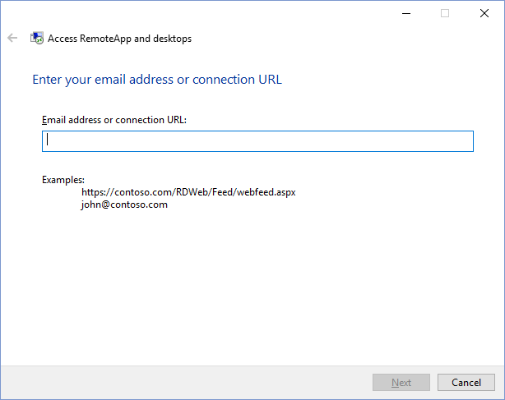

<https://msdn.microsoft.com/en-us/library/windows/desktop/ee330741(v=vs.85).aspx#RemoteAppAndDesktopConnections>

<http://c-nergy.be/blog/?p=4868>

<http://social.technet.microsoft.com/wiki/contents/articles/12837.managing-remote-apps-using-powershell-on-windows-server-2012.aspx>

C:\Windows\WinSxS\amd64_microsoft-windows-s..s-classicsearchdata_31bf3856ad364e35_10.0.10586.0_none_a76628a52d965d42

aaa_Classic_{7940ACF8-60BA-4213-A7C3-F3B400EE266D}

<http://ccmexec.com/2015/12/customizing-the-taskbar-in-windows-10-during-osd/>

Event ID

3000 Error Accessing Registry jrfc.dll RdsServer.cs

<http://stackoverflow.com/questions/8388964/how-can-i-inherit-the-string-class>

http://www.tenforums.com/tutorials/8974-shortcut-arrow-icon-change-remove-restore-windows-10-a.html

<https://msdn.microsoft.com/en-us/library/windows/desktop/Dd401668(v=vs.85).aspx>

<http://stackoverflow.com/questions/35600392/how-to-get-verb-for-pin-to-taskbar-in-windows-10>

<https://social.technet.microsoft.com/Forums/en-US/62973e48-0ef3-4f63-9e03-458e7bcf3778/pin-items-to-taskbar?forum=win10itprosetup>

"Windows 10" FavoritesResolve "HKEY_CURRENT_USER\SOFTWARE\Microsoft\Windows\CurrentVersion\Explorer\Taskband\Favorites"

D:\Temp>syspin /?

Pin To Taskbar Utility v0.95

Technosys Corporation, Copyright(c) 1998-2015, www.technosys.net

Non-Commercial Use Only Coded by Ceyhun OZGEN

Usage : syspin ["file"] c:#### or syspin ["file"] c:"commandstring"

c:5386 : Pin to Taskbar

c:5387 : Unpin from Taskbar

c:51201 : Pin to Start

c:51394 : Unpin to Start

Samples :

syspin "%PROGRAMFILES%\Internet Explorer\iexplore.exe" c:5386

syspin "C:\Windows\notepad.exe" c:"Pin to Taskbar"

syspin "%WINDIR%\System32\calc.exe" c:"Pin to Start"

syspin "C:\Windows\System32\calc.exe" c:51201

//TS Workspaces 1.0 Type Library

//Version: 1.0

WorkspaceTask;

GUID = {7071EC00-663B-4BC1-A1FA-B97F3B917C55};

//Setup a Workspace Task Class

CoClass WorkspaceSetupTask;

GUID = {7940ACF8-60BA-4213-A7C3-F3B400EE266D};

//IXWizardTaskEvent interface

Interface IXWizardTaskEvent;

GUID = {777BA8B2-2498-4875-933A-3067DE883070};

function CanHostTask(pguidParentHost: ^GUID; out ppHostDisplayData: ^^_XWIZARD_HOST_DISPLAY_TASK_INFO): HResult; stdcall;

function CanRunTask(hwndParent: wireHWND; pguidParentHost: ^GUID; eWizardType: tagXW_WIZARD_TYPE; dwUserFlags: UI4; pszCommandLine: LPWSTR; dwContextFlags: UI4; pIXWizardSource: ^IXWizardSource; out ppTaskData: ^^VOID): HResult; stdcall;

function CanRegisterPage(pguidPage: ^GUID): HResult; stdcall;

function CanUnregisterPage(pguidPage: ^GUID): HResult; stdcall;

function CanNavigatePage(pguidSourcePage: ^GUID; out pguidTargetPage: ^GUID): HResult; stdcall;

function OnRecyclePage(pguidPage: ^GUID; pguidPreviousPage: ^GUID): HResult; stdcall;

function OnGetWizardTypesSupported(out pdwWizardTypes: ^UI4): HResult; stdcall;

function OnApply: HResult; stdcall;

function OnReset: HResult; stdcall;

function OnCommit: HResult; stdcall;

function OnAbort: HResult; stdcall;

//IXWizardMessageEvent interface

Interface IXWizardMessageEvent;

GUID = {777BA824-2498-4875-933A-3067DE883070};

function OnError(pguidOriginComponent: ^GUID; dwResult: UI4; pszOptionalMessage: LPWSTR; dwMessageFlags: UI4): HResult; stdcall;

function OnDisplay(pguidOriginComponent: ^GUID; pszCaption: LPWSTR; pszText: LPWSTR; uiDialogType: UINT; out piDialogResult: ^INT; dwMessageFlags: UI4): HResult; stdcall;

function OnLog(pguidOriginComponent: ^GUID; pszCaption: LPWSTR; pszText: LPWSTR; wEventType: UI2; dwMessageFlags: UI4): HResult; stdcall;

Record _XWIZARD_HOST_DISPLAY_TASK_INFO;

dwVersion: UI4;

dwDisplayFlags: UI4;

guidTask: GUID;

pfnLoadImage: ^VOID;

hInstance: ^VOID;

pszIcon: LPWSTR;

pszViewName: LPWSTR;

pszTooltipName: LPWSTR;

Alias wireHWND;

^_RemotableHandle

Record _RemotableHandle;

fContext: I4;

u: __MIDL_IWinTypes_0009;

Union __MIDL_IWinTypes_0009;

hInproc: I4;

hRemote: I4;

Enum tagXW_WIZARD_TYPE;

XW_WIZARD_TYPE_NONE = 0;

XW_WIZARD_TYPE_PROPERTYSHEET97 = 1;

XW_WIZARD_TYPE_WIZARD97 = 2;

XW_WIZARD_TYPE_AERO = 32;

XW_WIZARD_TYPE_DUI = 512;

XW_WIZARD_TYPE_DUI_MODERN = 1024;

XW_WIZARD_TYPE_MAX = 1024;

//IXWizardSource interface

Interface IXWizardSource;

GUID = {777BA826-2498-4875-933A-3067DE883070};

//Workspace Setup Input Page Class

CoClass WorkspaceSetupInputPage;

GUID = {116ABC1A-F7DB-45A7-ADDA-D5A57A08C6FF};

//IXWizardPageEvent interface

Interface IXWizardPageEvent;

GUID = {777BA8C2-2498-4875-933A-3067DE883070};

function CanRunPage(pguidTask: ^GUID; pguidParentPage: ^GUID; eWizardType: tagXW_WIZARD_TYPE; dwUserFlags: UI4; pszCommandLine: LPWSTR; dwContextFlags: UI4; pIXWizardSource: ^IXWizardSource; out ppPageData: ^^VOID): HResult; stdcall;

function CanRegisterPage(pguidPage: ^GUID): HResult; stdcall;

function CanUnregisterPage(pguidPage: ^GUID): HResult; stdcall;

function CanNavigateChildPage(out pguidTargetPage: ^GUID): HResult; stdcall;

function OnRecycleChildPage(pguidPage: ^GUID): HResult; stdcall;

//IXWizardTransactionEvent interface

Interface IXWizardTransactionEvent;

GUID = {777BA828-2498-4875-933A-3067DE883070};

function OnApply: HResult; stdcall;

function OnReset: HResult; stdcall;

function OnCommit: HResult; stdcall;

function OnAbort: HResult; stdcall;

//Workspace Setup Discovery Page

CoClass WorkspaceSetupDiscoveryPage;

GUID = {33F3C8F8-27A1-4DF3-A525-E89CB18881A5};

//Workspace Setup Confirm Settings Page

CoClass WorkspaceSetupConfirmSettingsPage;

GUID = {984F9804-3314-4FA4-AC8C-E688D4133C51};

//Workspace Setup Configure Page

CoClass WorkspaceSetupConfigurePage;

GUID = {59CDB915-8232-46AD-B38B-497B8B0463AD};

//Workspace Setup Finish Page

CoClass WorkspaceSetupFinishPage;

GUID = {22B6E688-B3A5-44FC-B0CE-69F20653CD61};

//Workspace Setup Message Page

CoClass WorkspaceSetupMessagePage;

GUID = {3DECD5DD-A27B-48DC-8BAA-2682CFA265FF};

//Workspace Setup Message Page 2

CoClass WorkspaceSetupMessagePage2;

GUID = {165D4642-1278-4486-A3FD-439F5888FCA3};

//WorkspaceResTypeRegistry Class

CoClass WorkspaceResTypeRegistry;

GUID = {F2C4CDB0-2714-42AD-A948-2ED958A322E3};

//IWorkspaceResTypeRegistry Interface

Dispatch IWorkspaceResTypeRegistry;

GUID = {1D428C79-6E2E-4351-A361-C0401A03A0BA};

function QueryInterface(riid: ^GUID; out ppvObj: ^^VOID); stdcall;

function AddRef: UI4; stdcall;

function Release: UI4; stdcall;

function GetTypeInfoCount(out pctinfo: ^UINT); stdcall;

function GetTypeInfo(itinfo: UINT; lcid: UI4; out pptinfo: ^^VOID); stdcall;

function GetIDsOfNames(riid: ^GUID; rgszNames: ^^I1; cNames: UINT; lcid: UI4; out rgdispid: ^I4); stdcall;

function Invoke(dispidMember: I4; riid: ^GUID; lcid: UI4; wFlags: UI2; pdispparams: ^DISPPARAMS; out pvarResult: ^Variant; out pexcepinfo: ^EXCEPINFO; out puArgErr: ^UINT); stdcall;

//method AddResourceType

function AddResourceType(fMachineWide: Bool; bstrFileExtension: BSTR; bstrLauncher: BSTR); stdcall;

//method DeleteResourceType

function DeleteResourceType(fMachineWide: Bool; bstrFileExtension: BSTR); stdcall;

//method GetRegisteredFileExtensions

function GetRegisteredFileExtensions(fMachineWide: Bool): SafeArray; stdcall;

//method GetResourceTypeInfo

function GetResourceTypeInfo(fMachineWide: Bool; bstrFileExtension: BSTR): BSTR; stdcall;

//method ModifyResourceType

function ModifyResourceType(fMachineWide: Bool; bstrFileExtension: BSTR; bstrLauncher: BSTR); stdcall;

//WorkspaceInstaller Class

CoClass WorkspaceInstaller;

GUID = {8A95E9F1-1C07-4711-8DDA-10A35B26271E};

//IWorkspaceInstaller Interface

Interface IWorkspaceInstaller;

GUID = {3B4BE995-61E3-430C-8977-0B21E4427BE7};

//method InitWorkspaceAdvise

function InitWorkspaceAdvise(out phWnd: ^ULONG_PTR): HResult; stdcall;

//method SetUpWorkspaceAdvise

function SetupWorkspaceAdvise(pWkspSetupNotify: ^IWorkspaceSetupNotify): HResult; stdcall;

//method SubscribeToWorkspace

function SubscribeToWorkspace(bstrAppContainer: BSTR; hwndParent: ULONG_PTR): HResult; stdcall;

Alias ULONG_PTR;

UI4

//IWorkspaceSetupNotify Interface

Interface IWorkspaceSetupNotify;

GUID = {B91E9062-52BE-4D45-ADF3-FCAEF08E9478};

//method OnUpdateWorkspace

function OnUpdateWorkspace(out __MIDL__IWorkspaceSetupNotify0000: UI4): HResult; stdcall;

//method GetContainerWindow

function GetContainerWindow(out phWnd: ^ULONG_PTR): HResult; stdcall;

//RADCApiWorkspaceManager Class

CoClass RADCApiWorkspaceManager;

GUID = {09655E95-040C-4654-85AF-48852407FDD9};

//IRADCWorkspaceManager Interface

Dispatch IRADCWorkspaceManager;

GUID = {EBD94DE1-1FCE-4893-A7EB-6CB18630C0C3};

function QueryInterface(riid: ^GUID; out ppvObj: ^^VOID); stdcall;

function AddRef: UI4; stdcall;

function Release: UI4; stdcall;

function GetTypeInfoCount(out pctinfo: ^UINT); stdcall;

function GetTypeInfo(itinfo: UINT; lcid: UI4; out pptinfo: ^^VOID); stdcall;

function GetIDsOfNames(riid: ^GUID; rgszNames: ^^I1; cNames: UINT; lcid: UI4; out rgdispid: ^I4); stdcall;

function Invoke(dispidMember: I4; riid: ^GUID; lcid: UI4; wFlags: UI2; pdispparams: ^DISPPARAMS; out pvarResult: ^Variant; out pexcepinfo: ^EXCEPINFO; out puArgErr: ^UINT); stdcall;

//method GetWorkspaceFromID

function GetWorkspaceFromID(guid: BSTR): ^IRADCWorkspace; stdcall;

//method GetNumWorkspaces

function GetNumWorkspaces: UI4; stdcall;

//method GetWorkspaceIDs

function GetWorkspaceIDs: SafeArray; stdcall;

//method DeleteWorkspace

function DeleteWorkspace(guid: BSTR); stdcall;

//method IsWorkspaceUrlUnique

function IsWorkspaceUrlUnique(URL: BSTR): Bool; stdcall;

//IRADCWorkspace Interface

Dispatch IRADCWorkspace;

GUID = {3D0C78BF-98BF-4B97-835E-E4269F8E038D};

function QueryInterface(riid: ^GUID; out ppvObj: ^^VOID); stdcall;

function AddRef: UI4; stdcall;

function Release: UI4; stdcall;

function GetTypeInfoCount(out pctinfo: ^UINT); stdcall;

function GetTypeInfo(itinfo: UINT; lcid: UI4; out pptinfo: ^^VOID); stdcall;

function GetIDsOfNames(riid: ^GUID; rgszNames: ^^I1; cNames: UINT; lcid: UI4; out rgdispid: ^I4); stdcall;

function Invoke(dispidMember: I4; riid: ^GUID; lcid: UI4; wFlags: UI2; pdispparams: ^DISPPARAMS; out pvarResult: ^Variant; out pexcepinfo: ^EXCEPINFO; out puArgErr: ^UINT); stdcall;

//method Init

function Init(ID: BSTR); stdcall;

//get URL

property-get URL: BSTR; stdcall;

//get ID

property-get ID: BSTR; stdcall;

//get DefaultStatus

property-get DefaultStatus: Bool; stdcall;

//get Publisher

property-get Publisher: BSTR; stdcall;

//get WorkspaceID

property-get WorkspaceID: BSTR; stdcall;

//get PublisherNameSuffix

property-get PublisherNameSuffix: UI4; stdcall;

//get UniquePublisherName

property-get UniquePublisherName: BSTR; stdcall;

//get SupportsReconnect

property-get SupportsReconnect: Bool; stdcall;

//get ResourceCount

property-get ResourceCount: UI4; stdcall;

//get RdpFilesDownloadedCount

property-get RdpFilesDownloadedCount: UI4; stdcall;

//get IconsDownloadedCount

property-get IconsDownloadedCount: UI4; stdcall;

//get StartMenuProgramsCount

property-get StartMenuProgramsCount: UI4; stdcall;

//get StartMenuComputersCount

property-get StartMenuComputersCount: UI4; stdcall;

//method GetCreationTime

function GetCreationTime(out dwTimeLow: ^UI4; out dwTimeHigh: ^UI4); stdcall;

//method GetLastUpdateTime

function GetLastUpdateTime(out dwTimeLow: ^UI4; out dwTimeHigh: ^UI4); stdcall;

//method GetLastAttemptTime

function GetLastAttemptTime(out dwTimeLow: ^UI4; out dwTimeHigh: ^UI4); stdcall;

//method GetFirstFailureTime

function GetFirstFailureTime(out dwTimeLow: ^UI4; out dwTimeHigh: ^UI4); stdcall;

//get LastAttemptStatus

property-get LastAttemptStatus: RADCAPI_RESULT_STATUS; stdcall;

//get LastAttemptTitle

property-get LastAttemptTitle: BSTR; stdcall;

//get LastAttemptDetail

property-get LastAttemptDetail: BSTR; stdcall;

//get StartMenuFolder

property-get StartMenuFolder: BSTR; stdcall;

//get RegistryRoot

property-get RegistryRoot: BSTR; stdcall;

Alias RADCAPI_RESULT_STATUS;

__MIDL___MIDL_itf_workspace_0001_0026_0001

Enum __MIDL___MIDL_itf_workspace_0001_0026_0001;

RADCAPI_UPDATE_SUCCESS = 0;

RADCAPI_UPDATE_WARNING = 1;

RADCAPI_UPDATE_FAIL = 2;

//RADCApiWorkspace Class

CoClass RADCApiWorkspace;

GUID = {F857B5CD-68AD-4012-8527-AB3A8E56F620};

**Your Serial Number for InstallShield Limited Edition:**

**2C1D2QW-D20-21600E7A4N**

.Lnk file format

<https://msdn.microsoft.com/en-us/library/dd891294.aspx>

Windows 7

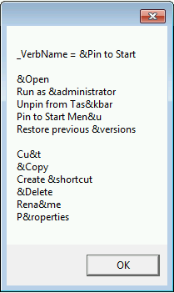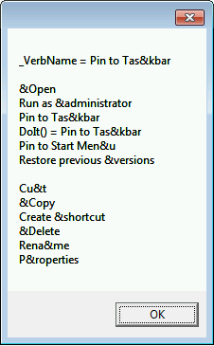

Windows 8

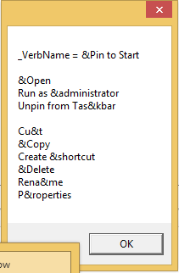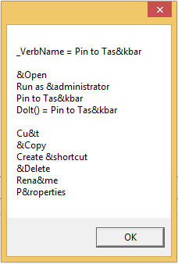

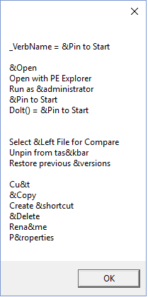Windows 10

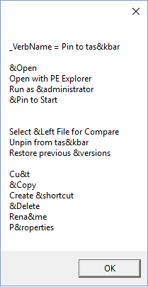

<https://msdn.microsoft.com/windows/uwp/controls-and-patterns/segoe-ui-symbol-font>